Press release

Artares louvred roof from Weinor
Simple and secure installation

For the technical conception of the new Artares louvred roof, sun and weather protection specialist Weinor focussed specially on simple, fast installation and easy maintenance. This is made possible, for example, by its high pre-manufactured content, cabling which only needs to be plugged in and good accessibility of the individual components. During an intensive product and installation training session, the Weinor retailers are comprehensively familiarised with the new product.

When developing the Artares louvred roof, we focused on installation to take as little effort or costs as possible. The new product “Made in Germany” was intended to be easy and installable according to the principle of modularity. Therefore, error sources which can occur during installation were already minimised in advance. Moreover, the Weinor partners will be intensively trained by experienced Weinor experts for the installation and maintenance of the new louvred roof, so that they now have sound knowledge of the product.

Flawless installation due to several clever details
The pre-assembled profiles can be assembled easily and safely. Sturdy metric screws replace the otherwise commonplace self-tapping screws for connecting the weight-bearing parts. The post bases are height-adjustable and can easily compensate uneven bases or surfaces.

For Artares, it is not even necessary to set the motor end positions. Moreover, as part of a clever cabling concept, all electrical components are mounted ready to plug in and are already integrated into the profiles weather-protected and concealed. This means that they not only enable simple and error-free installation, but also offer a seamless look.

Good accessibility for easy maintenance
The inspection chamber on the inside of the frame provides constant, easy access for specially qualified personnel, thus facilitating installation and maintenance. The louvres and motor drive are also placed in a maintenance-friendly position, making unproblematic louvre motor replacement possible. The corner joints are easily externally accessible, enabling the maintenance personnel easy reach of the radio control components and access to the drainage outlet.

Diverse versions to suit all customer requests
The durable Artares louvred roof is available as a free-standing version or mounted on the building facade. Also coupled systems with up to four sections and a covered area of up to 108 m² in longitudinal or transverse direction are possible. Artares is designed for heavy snow loads which are dependent on the unit size. For example, with medium size, the roof system bears a load of more than 400 kg/m². Upon request, Artares can also be realised with special engineering in combination with glass sliding doors w17 easy. With its cubic shape and no visually perceptible pitch, the louvred roof meets the highest requirements for sophisticated design.

The Weinor louvred roof has an automatic system controller and can be extended in many ways with integrated vertical sun protection, coloured and white light LEDs as well as a heating system. This provides Weinor’s partners with several selection options for their customers and attractive additional business.

Media contact:
Christian Pätz
Weinor GmbH & Co. KG || Mathias-Brüggen-Str. 110 || D-50829 Köln
E-mail: cpaetz@weinor.de || weinor.de
Tel.: +49 (0)221 / 597 09 265 || Fax: +49 (0)221/ 595 11 89
Image material:

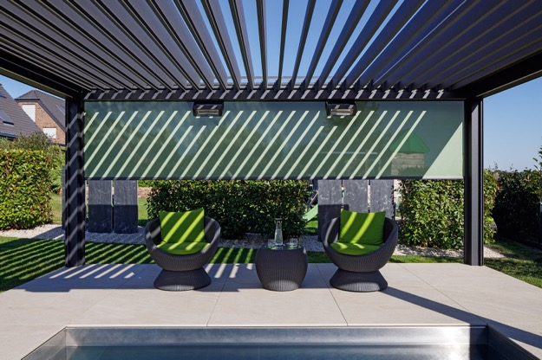
Image 1:
The Artares louvred roof provides individually adjustable weather protection
with attractive interplay of light and shade.

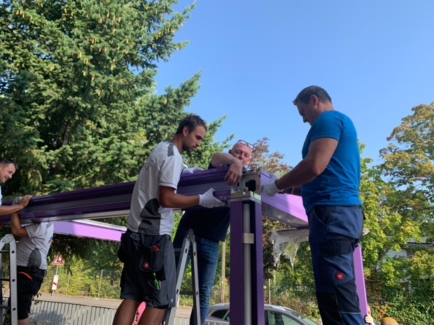
Image 2:
During the intense training, the easy
installation of the roof profiles in accordance with the principle of modularity is instructed.

Photos: Weinor GmbH & Co. KG

